Asp.net guide on connecting & coding
Prepared By :Eng. Mubiru Abubakari
0700615681 | mubiruabubakari@gmail.com

Create a database in mysql server called mtn and table called client
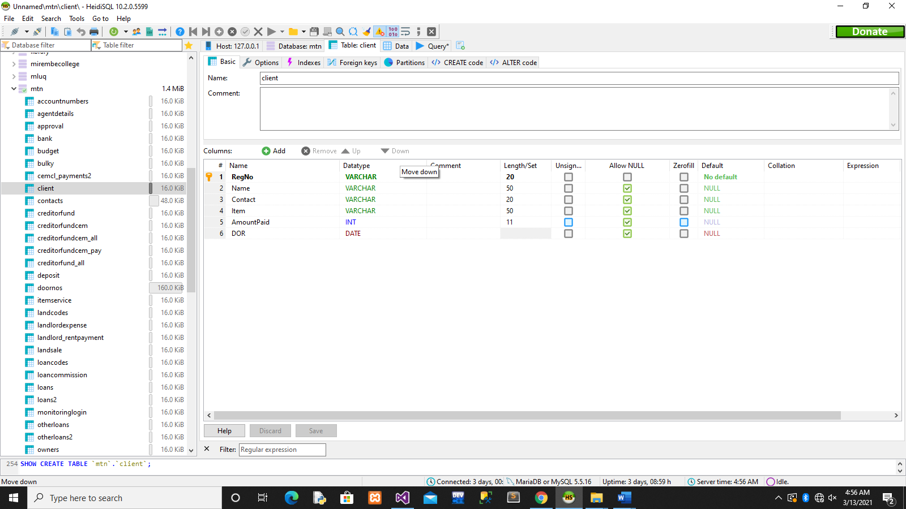

Online application created using visual basic 2013



ID: cmdUpdate
ID: cmddel
ID: cmdClear
ID : cmdsave
ID : ii
ID : f
ID : d
ID : c
ID : b

ID : a
Adding reference

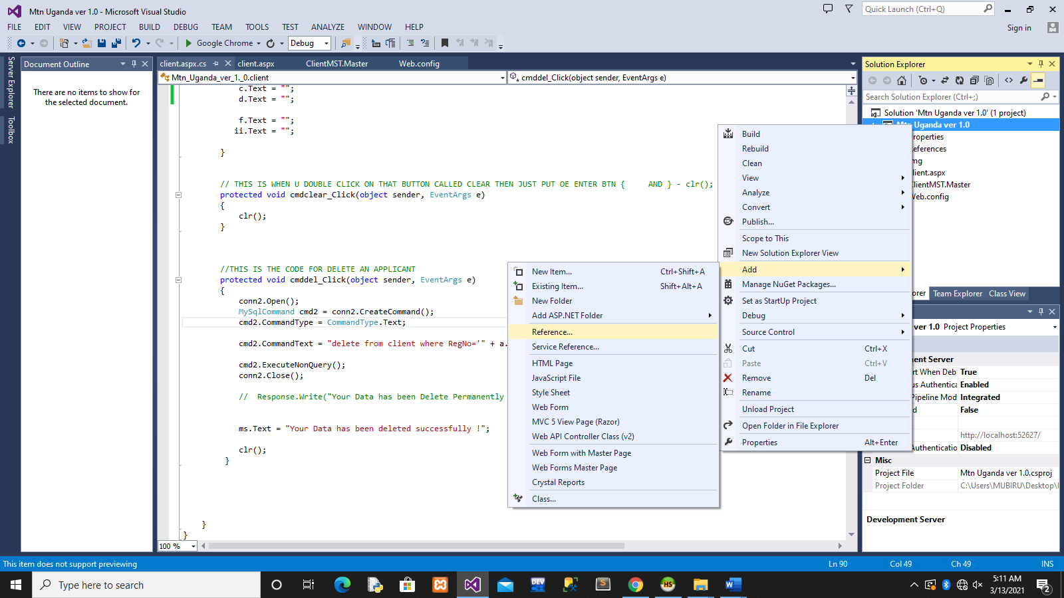
Look were you installed mysql connector (program files (86) under mysql folder the u will see mysql connector = Assemblies=v2 and v4
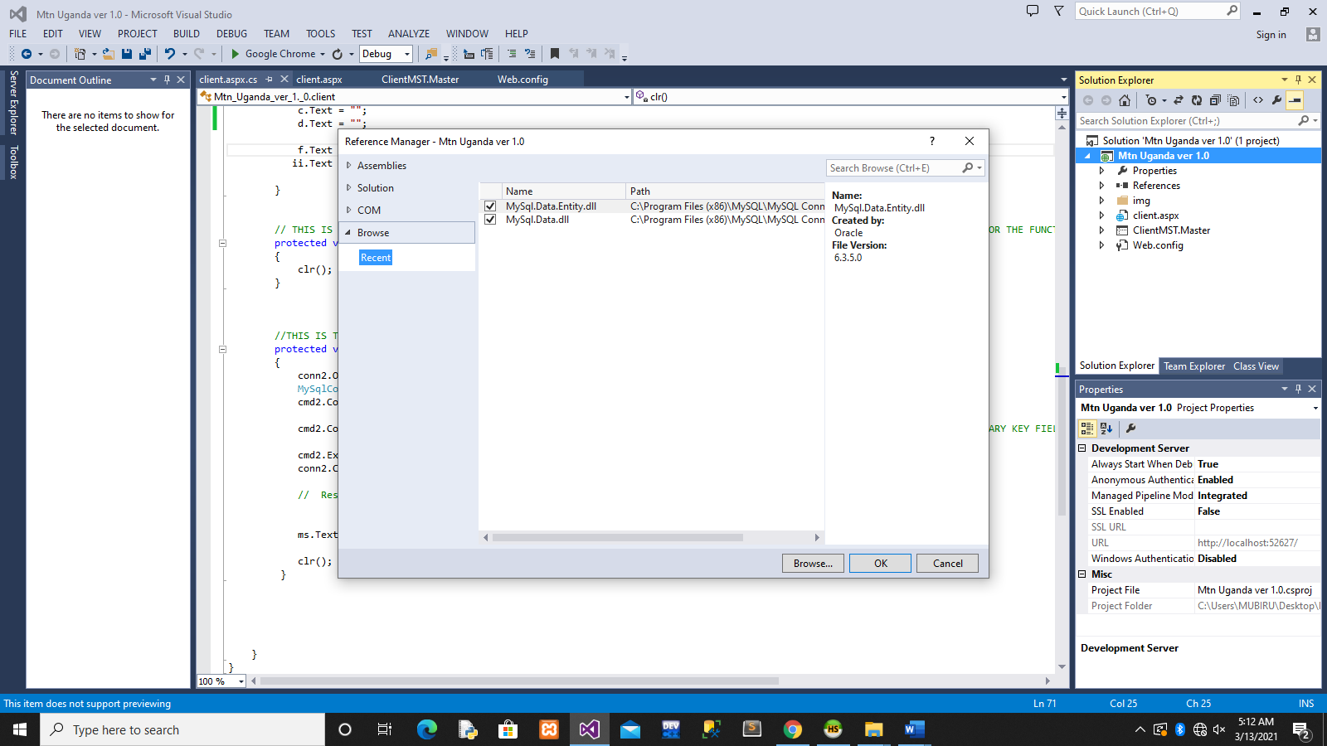

OPEN (WEB.CONFIG) FROM SOLUTION ON YOUR RIGHT PANEL

<?xml version="1.0"?>

<!--
For more information on how to configure your ASP.NET application, please visit
http://go.microsoft.com/fwlink/?LinkId=169433
-->

<configuration>

<!--
Eng Mubiru Code note ,please copy this copy from my notes and paste here connectionStrings and name use any = (MtnAppConnString) or maintain it for codes
and change database =mtn

-->

<connectionStrings>
<add name="MtnAppConnString" connectionString="server=127.0.0.1;User ID=root;Password=;Database=mtn;"
providerName="MySqlData.MySqlClient" />
</connectionStrings>

<system.web>
<compilation debug="true" targetFramework="4.0" />
</system.web>

</configuration>

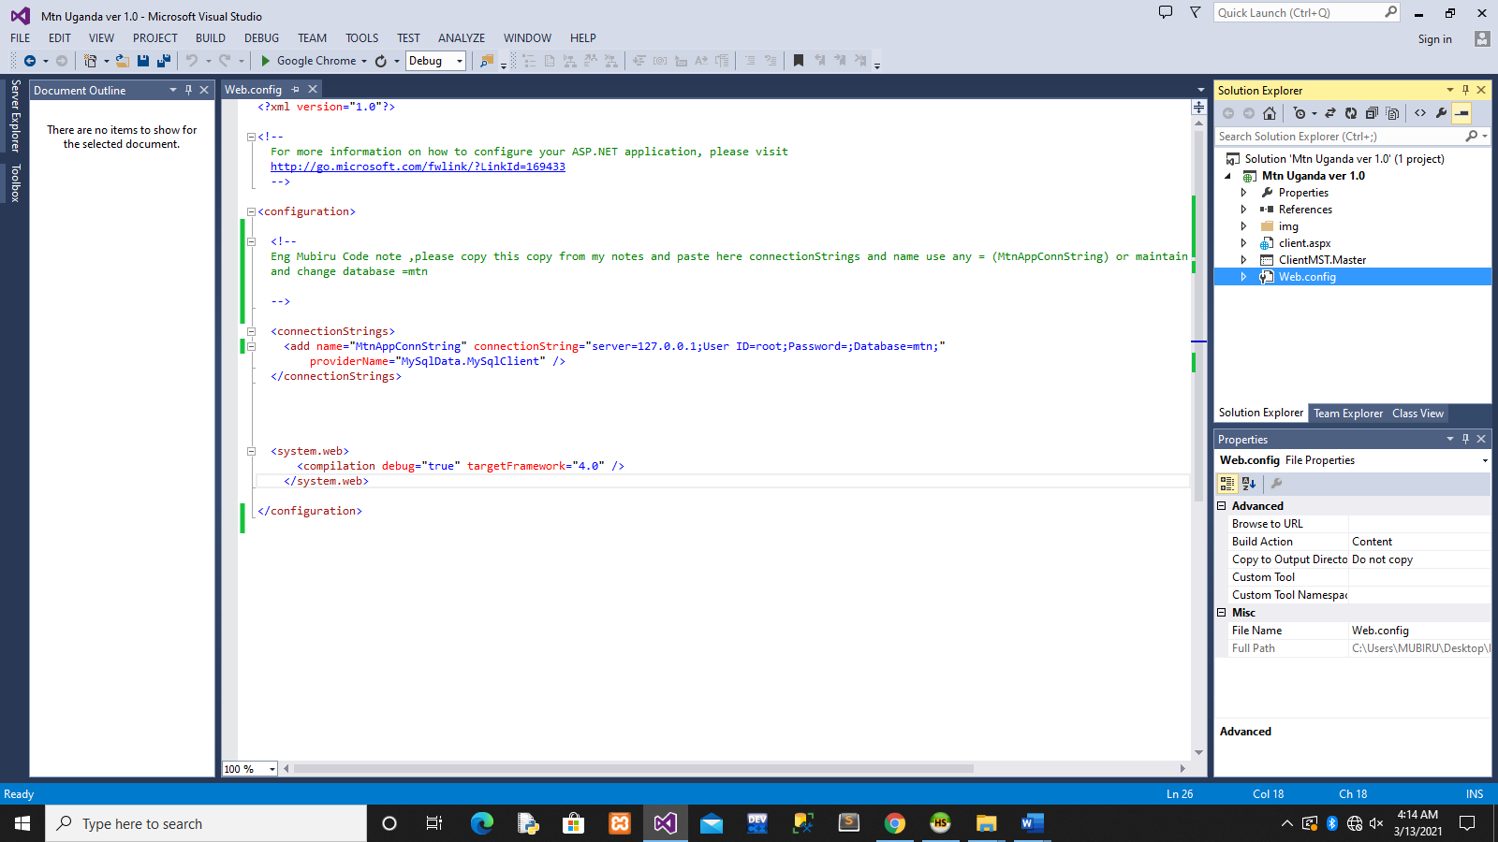

CODING STARTS FROM HERE USING C# (C SHARP LANGUAGE) WITH ASP.NET
Note that if copying, then code section by section not all at once
using System;
using System.Collections.Generic;
using System.Linq;
using System.Web;
using System.Web.UI;
using System.Web.UI.WebControls;

//HERE THESE TWO CODE MISSING, SO COPY AND PUT THEM HERE
using MySql.Data.MySqlClient;
using System.Data;

namespace Mtn_Uganda_ver_1._0
{
public partial class client : System.Web.UI.Page
{

//PLEASE CODE THIS SECTION OF CODE BTN THE START OF HERE AND CHANGE DATABASE(OR CALLED CATALOG=mtn (your database name)

MySql.Data.MySqlClient.MySqlConnection conn;
MySql.Data.MySqlClient.MySqlCommand cmd;
String queryStr;

MySqlConnection conn2 = new MySqlConnection(@"Data Source=localhost;port=3306;Initial Catalog=mtn;User Id=root;Password=''");

// END OF CODE COPIED ABOVE

//for saving into the database or submit data
protected void cmdsave_Click(object sender, EventArgs e)
{

//PLEASE NOTE THAT THE NAME YOU USED IN CONNECTIONSTRING IN XML OR WEB.CONFIG,SHOULD BE THE SAME HERE = (MtnAppConnString)

String ConnString = System.Configuration.ConfigurationManager.ConnectionStrings["MtnAppConnString"].ToString();

conn = new MySql.Data.MySqlClient.MySqlConnection(ConnString);

conn.Open();

queryStr = "";

//HERE U MUST NAME ALL OUR TEXTBOXES GOING TO BE USED IN SAVING DATA E.G FOR REGNO(ID = a), NAME TEXTBOX (ID =b),Contact (ID=c) etc

queryStr = "INSERT INTO mtn.client(RegNo,Name,Contact,Item,AmountPaid,DOR)" +
"VALUES('" + a.Text + "','" + b.Text + "','" + c.Text + "','" + d.Text + "','" + f.Text + "','" + ii.Text + "')";

cmd = new MySql.Data.MySqlClient.MySqlCommand(queryStr, conn);

cmd.ExecuteReader();
conn.Close();

//Response.Write("Your Data has been saved successfully !");
ms.Text = "Your Data has been saved successfully !";

clr();
}

// THIS CODE DOWN HERE , IS A FUNCTION WHICH CLEARS FOR NEXT APPLICANT AND WHY A FUNCTION, TO BE USED FOR MANY TIMES
private void clr()
{
a.Text = "";
b.Text = "";
c.Text = "";
d.Text = "";

f.Text = "";
ii.Text = "";

}

// THIS IS WHEN U DOUBLE CLICK ON THAT BUTTON CALLED CLEAR THEN JUST PUT OE ENTER BTN { AND } - clr(); THE WILL COME FOR THE FUNCTION
protected void cmdclear_Click(object sender, EventArgs e)
{
clr();
}

//THIS IS THE CODE FOR DELETE AN APPLICANT
protected void cmddel_Click(object sender, EventArgs e)
{
conn2.Open();
MySqlCommand cmd2 = conn2.CreateCommand();
cmd2.CommandType = CommandType.Text;

cmd2.CommandText = "delete from client where RegNo='" + a.Text + "'"; //THIS IS THE CODE WHICH DELETES USING OUR PRIMARY KEY FIELD REGNO=" THE REGNO U WILL ENTER IN TEXT a

cmd2.ExecuteNonQuery();
conn2.Close();

// Response.Write("Your Data has been Delete Permanently !"); // TRY TO REMOVE THIS COMMENT AND SEE WHAT IT DOES

ms.Text = "Your Data has been deleted successfully !";

clr();
}

}
}

//FOR UPDATE CODE IS HERE (double click update button and put
conn2.Open();
MySqlCommand cmd2 = conn2.CreateCommand();
cmd2.CommandType = CommandType.Text;

cmd2.CommandText = "update client set RegNo='" + a.Text + "',Name='" + c.Text + "' where RegNo='" + a.Text + "'";

cmd2.ExecuteNonQuery();
conn2.Close();

Response.Write("Your Data has been Updated Successfully !");

clr();

NOTE
Please make use of my codes for web development/Application/Business Application Programming as we did I class and copy code section by section or know how to fix but better where u typing yourself for exams practice.

Prepared By
Eng. Mubiru Abubakari
0700615681 | mubiruabubakari@gmail.com
Tools to use
- IDE = interface designing using Visual Basic 2013
- MySql as a server
- MySql Connector
Start your own nice project for your final project to submit last.

